**Software Design Document - Appendix F – Dialog Screens**

1. **SignUpScreen: Fields are empty**

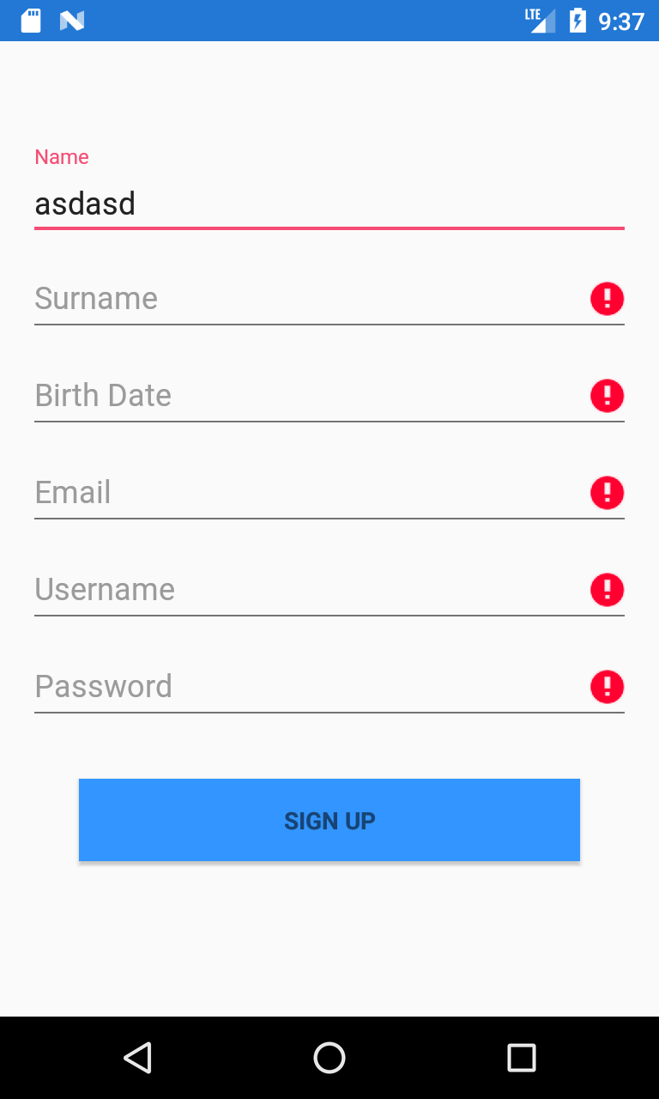

1. **SignUpScreen: Successful registration**

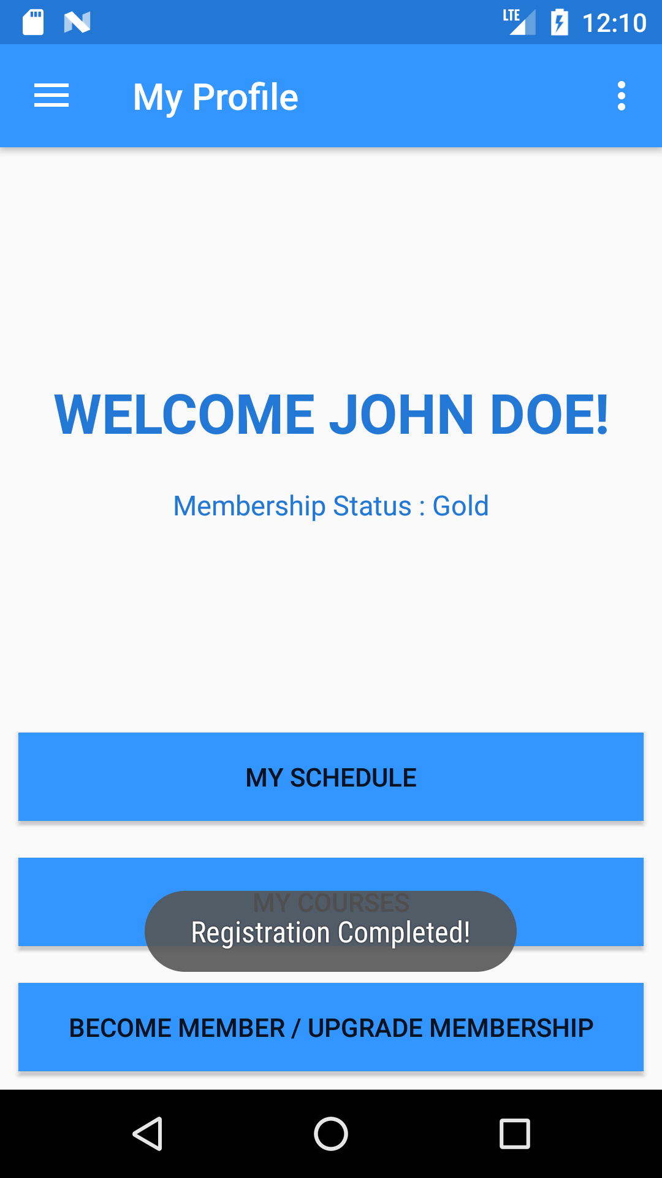

1. **SignInScreen: Username already taken**

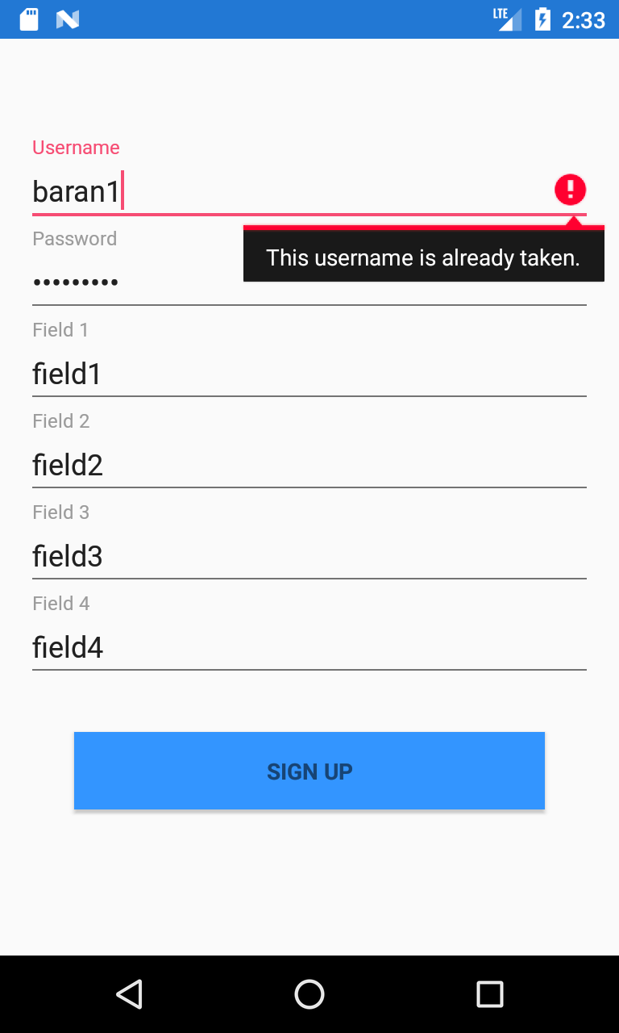

1. **SignInScreen: User type is not selected**

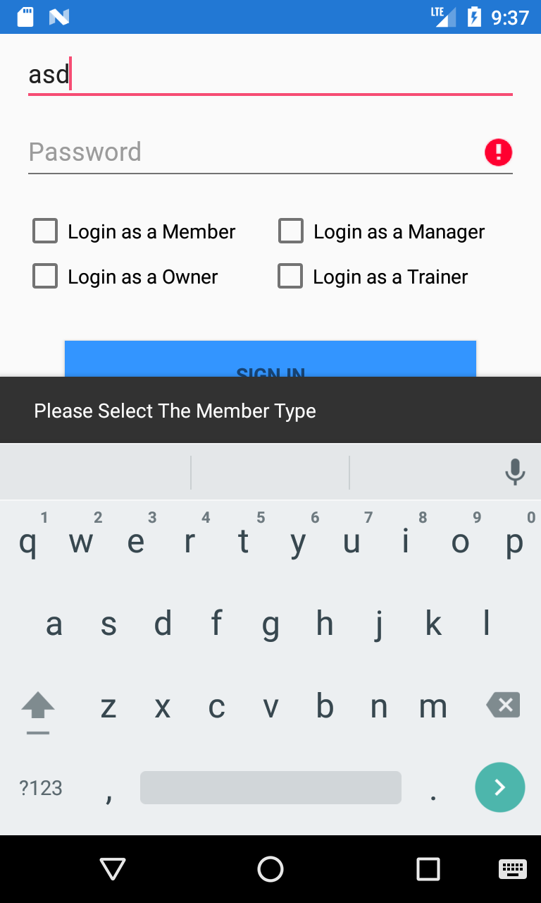

1. **SignInScreen: Fields are empty**

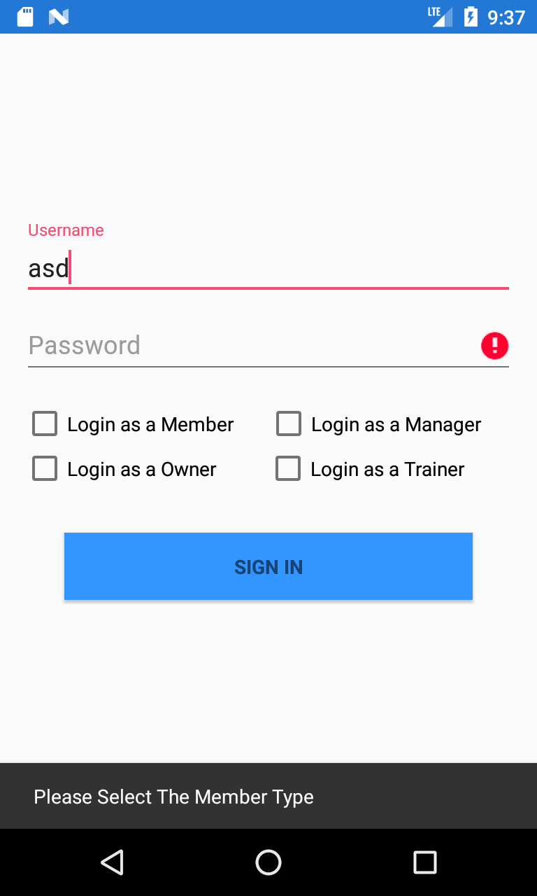

1. **SignInScreen : Invalid username&password**

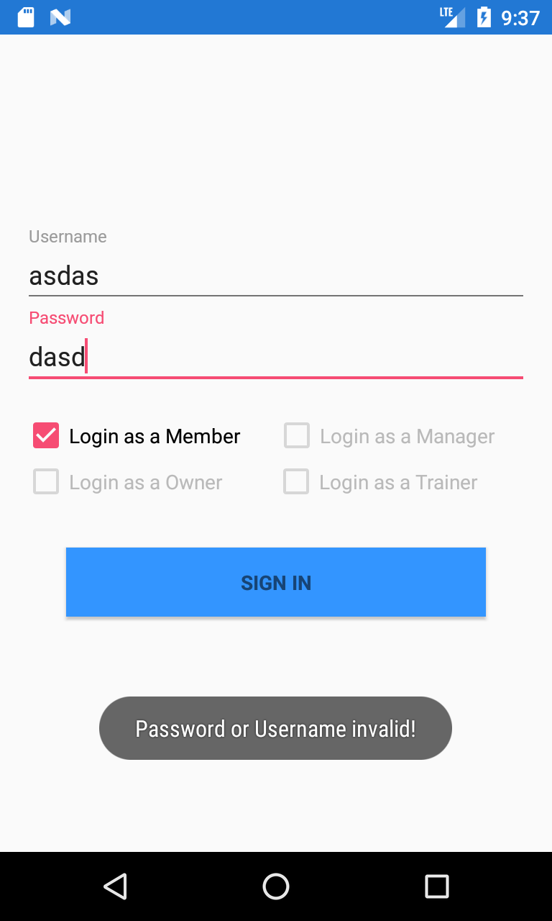

1. **PaymentScreen: Are You Sure?**

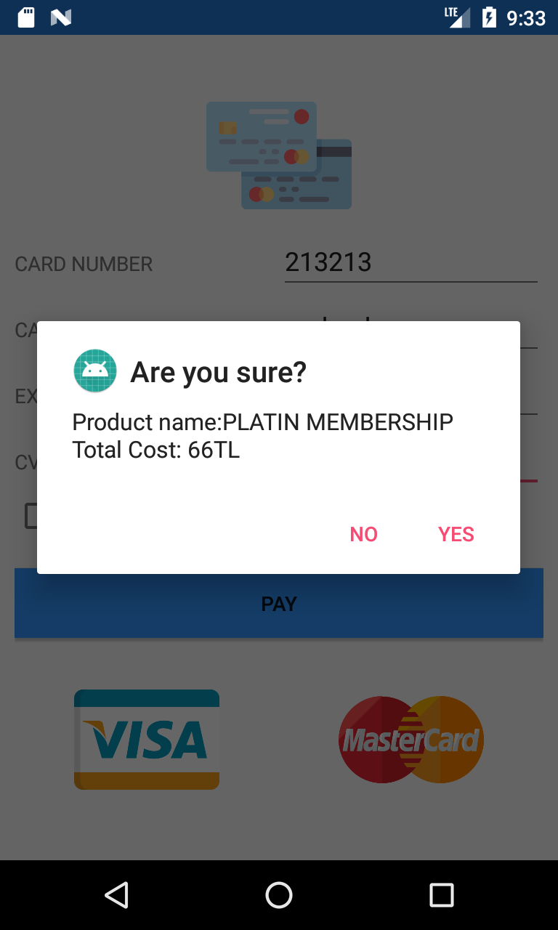

1. **PaymentScreen: Fields are empty**

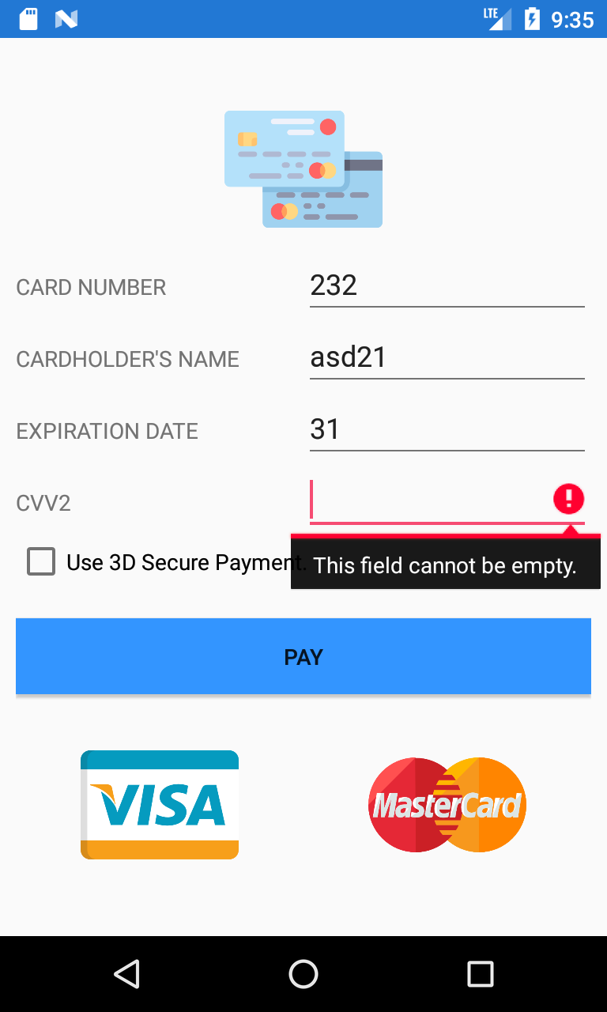

1. **UpdateProfileScreen: Fields are empty**

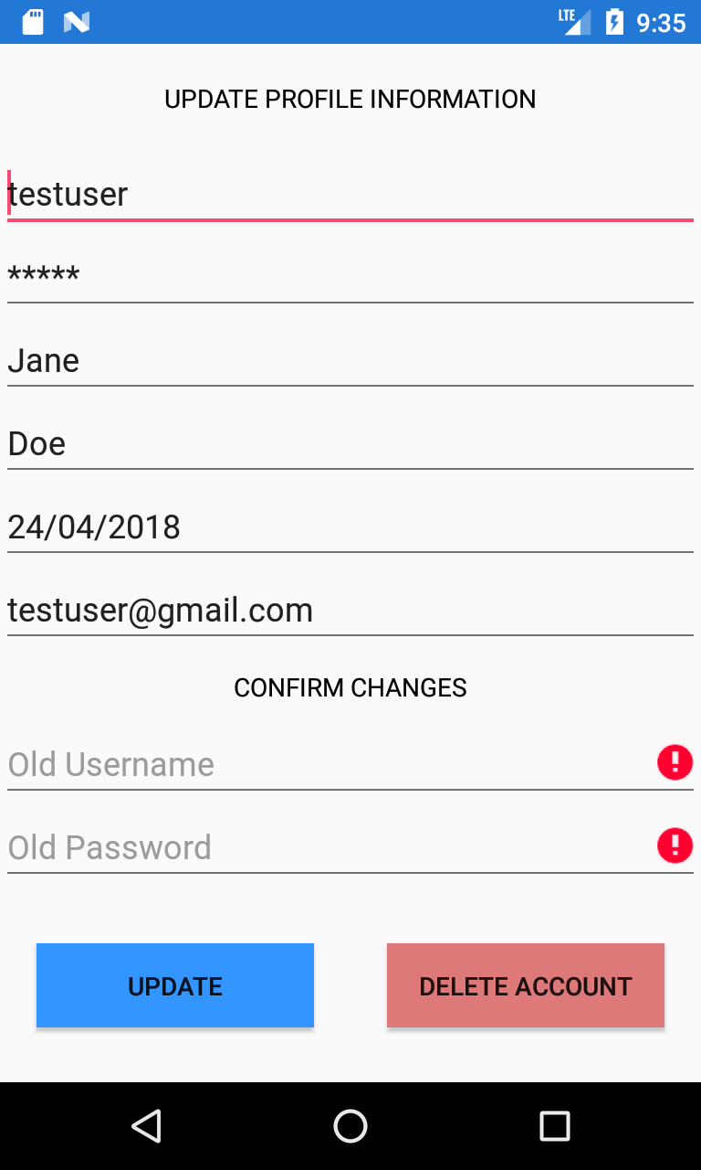

1. **UpdateProfileScreen: Successful update**

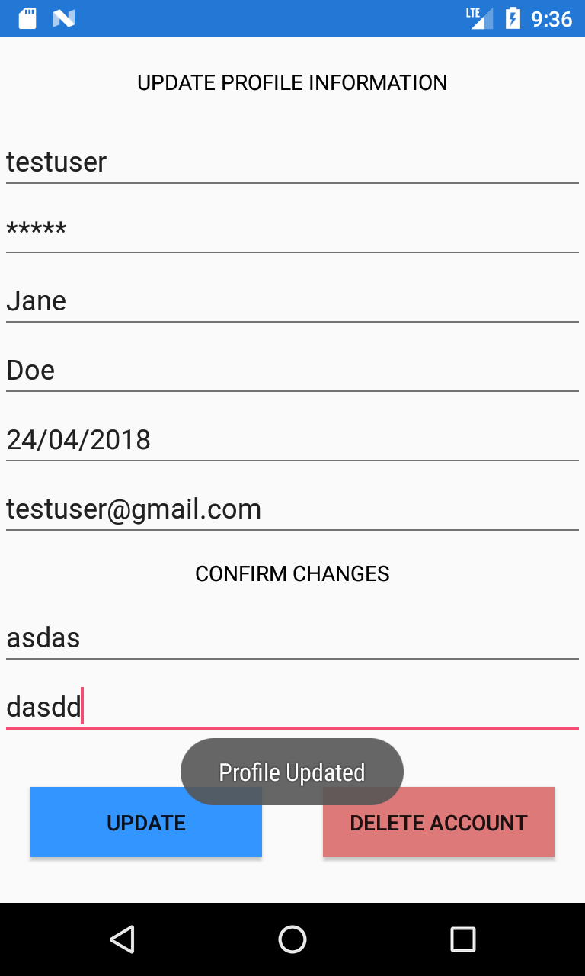

1. **FragmentMyProfile: Confirm logout**

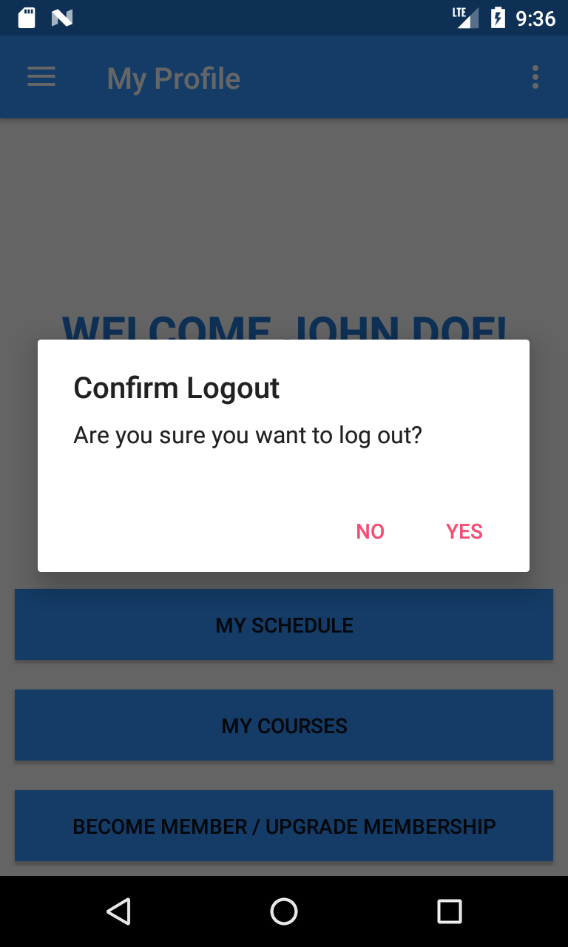

1. **CancelMembershipScreen: Fields are empty**

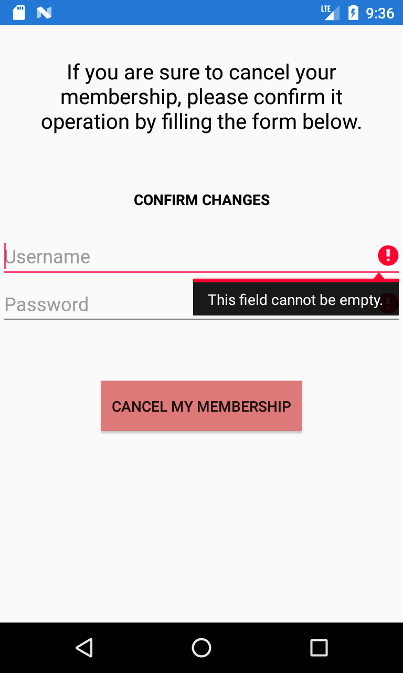

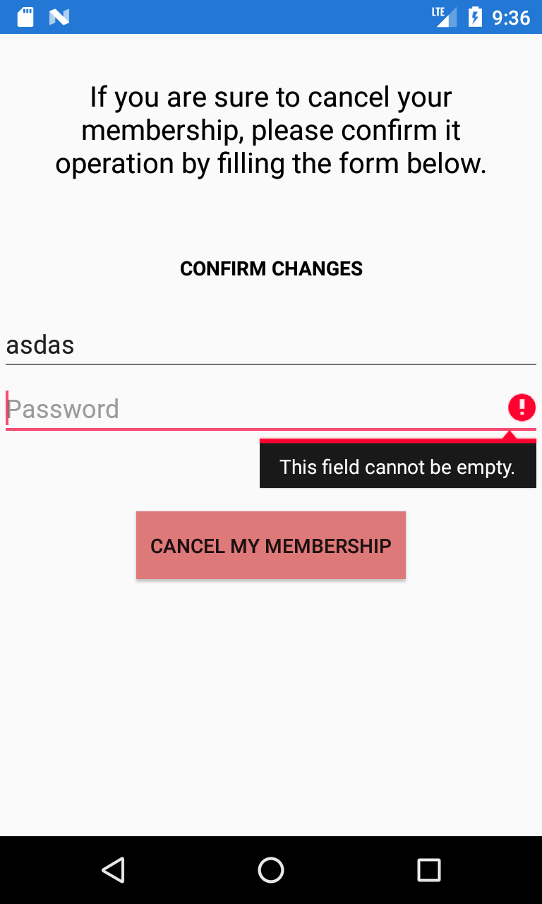

1. **CancelMembershipScreen: Invalid username&password**

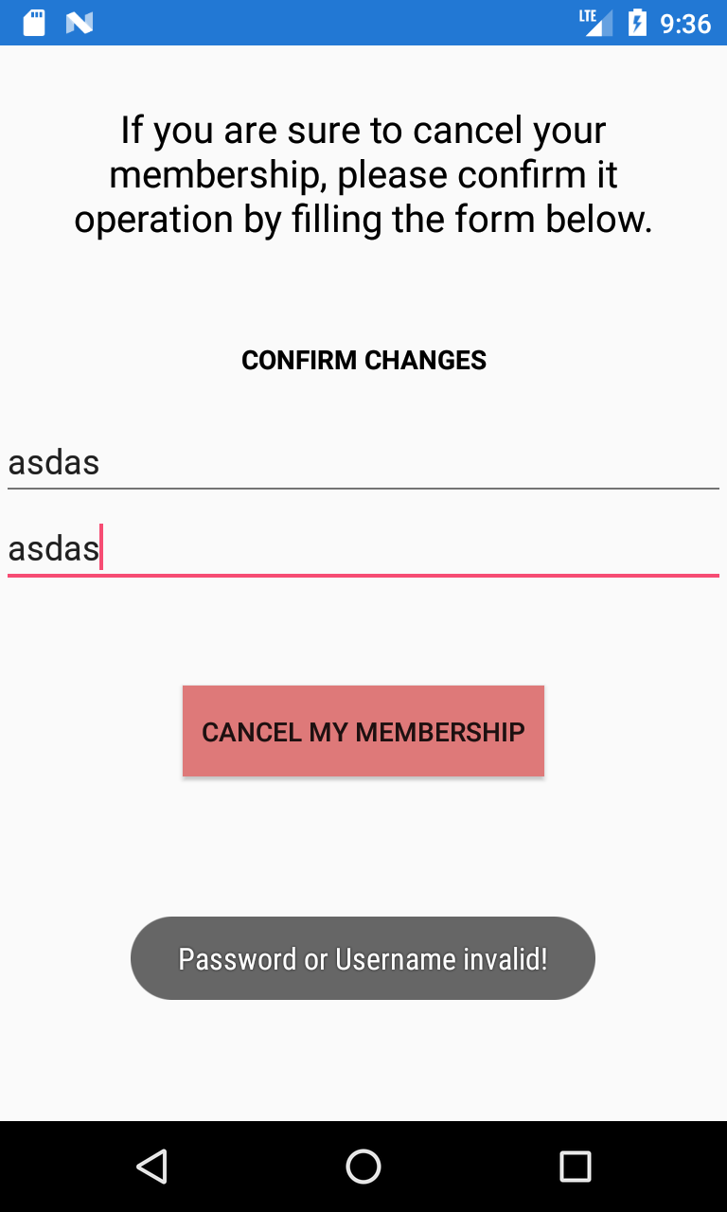

1. **CancelMembershipScreen: Successful cancellation**

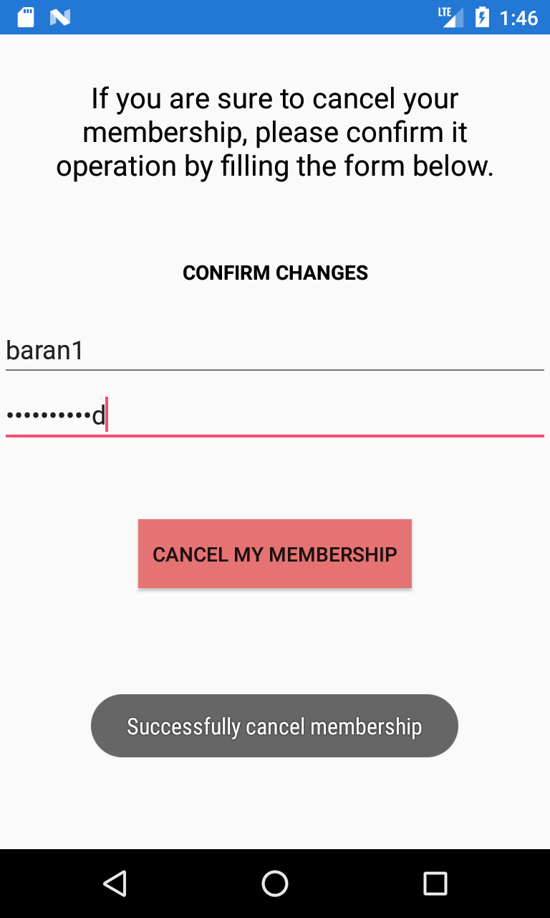

1. **FragmentCourse: Successful enrollment**

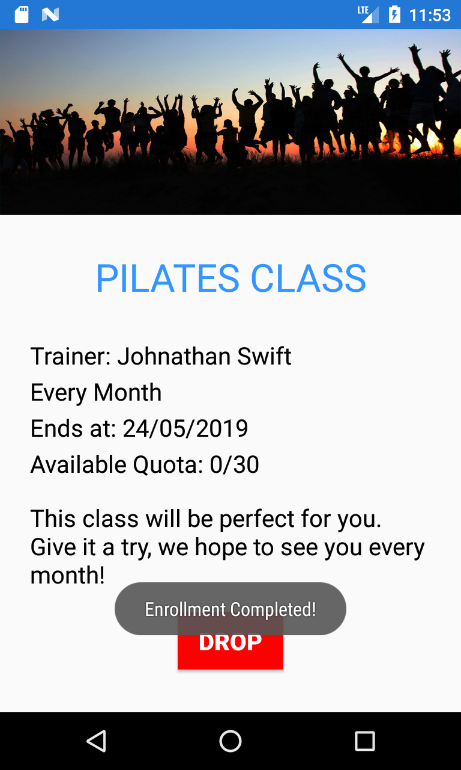

1. **FragmentCourse: Quota is full – Button in not interactable form**



1. **FragmentCourse: Succesful Drop**



1. **FragmentSpecialOffer: Successful registration**



1. **FragmentSpecialOffer: Conditions were not met**

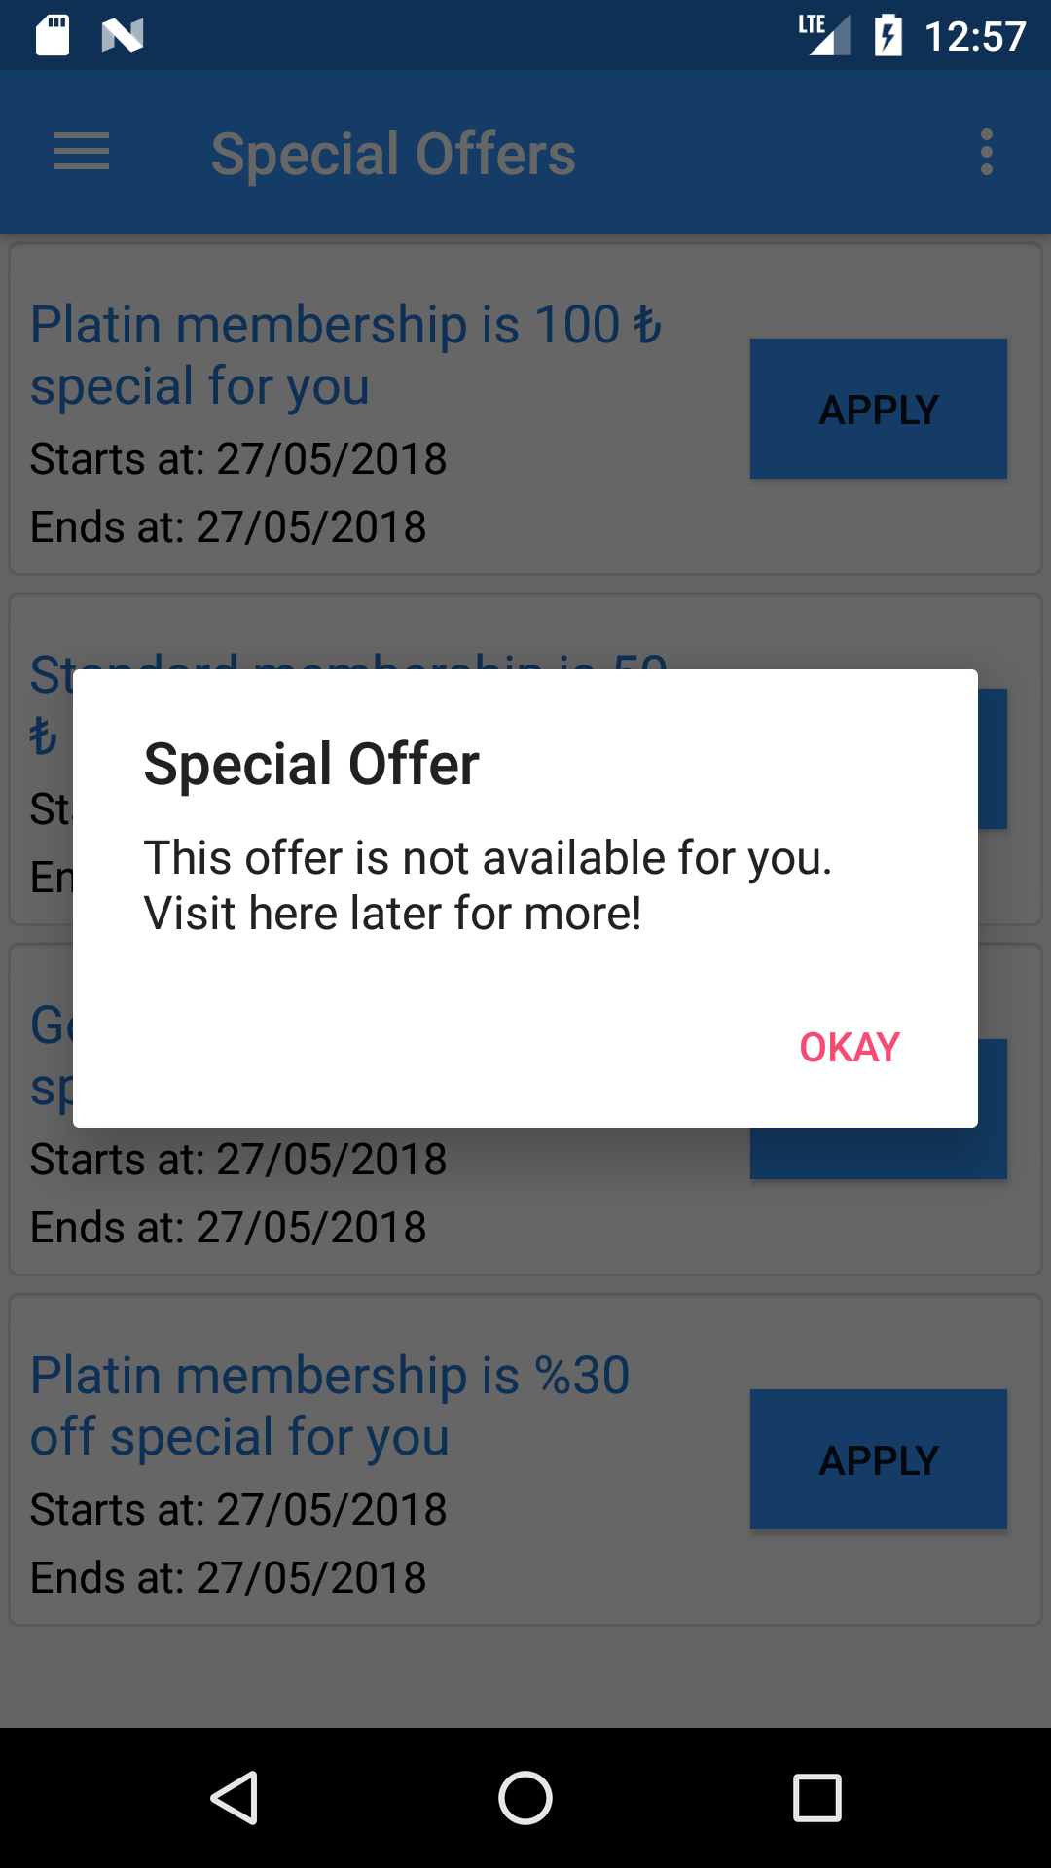

1. **FragmentManagementPanel (All Views): Are You Sure?**

**FragmentCourse: Are You Sure?**

**CancelMembershipScreen: Are You Sure?**

**UpdateProfileScreen: Are You Sure?**

**PaymentScreen: Are You Sure?**



1. **ManagerManagementScreen: Fields are empty**

**UserManagementScreen: Fields are empty**

**TrainerManagementScreen: Fields are empty**

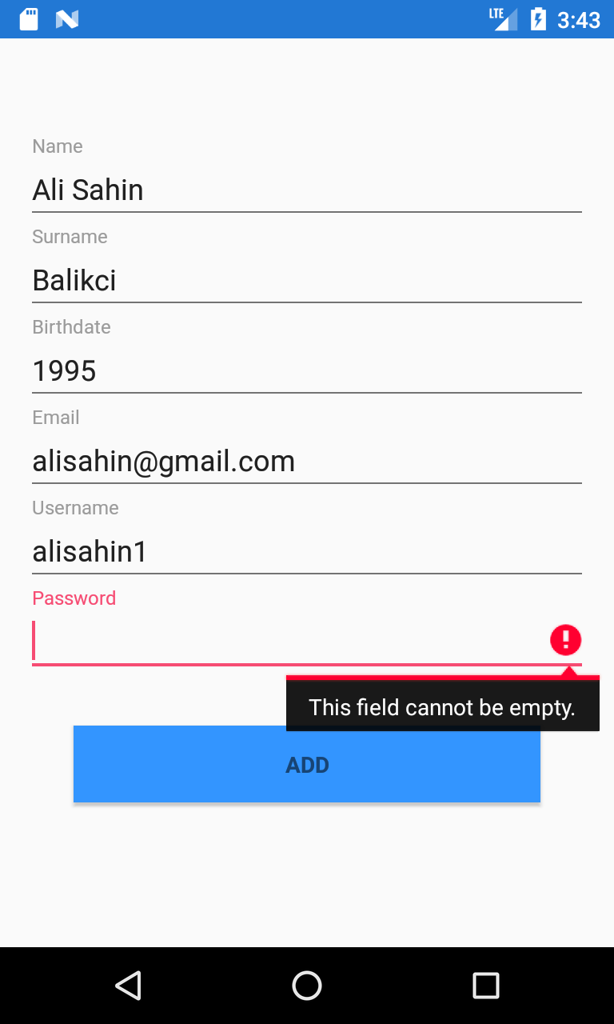

1. **ManagerManagementScreen: Username already taken**

**UserManagementScreen: Username already taken**

**TrainerManagementScreen: Username already taken**

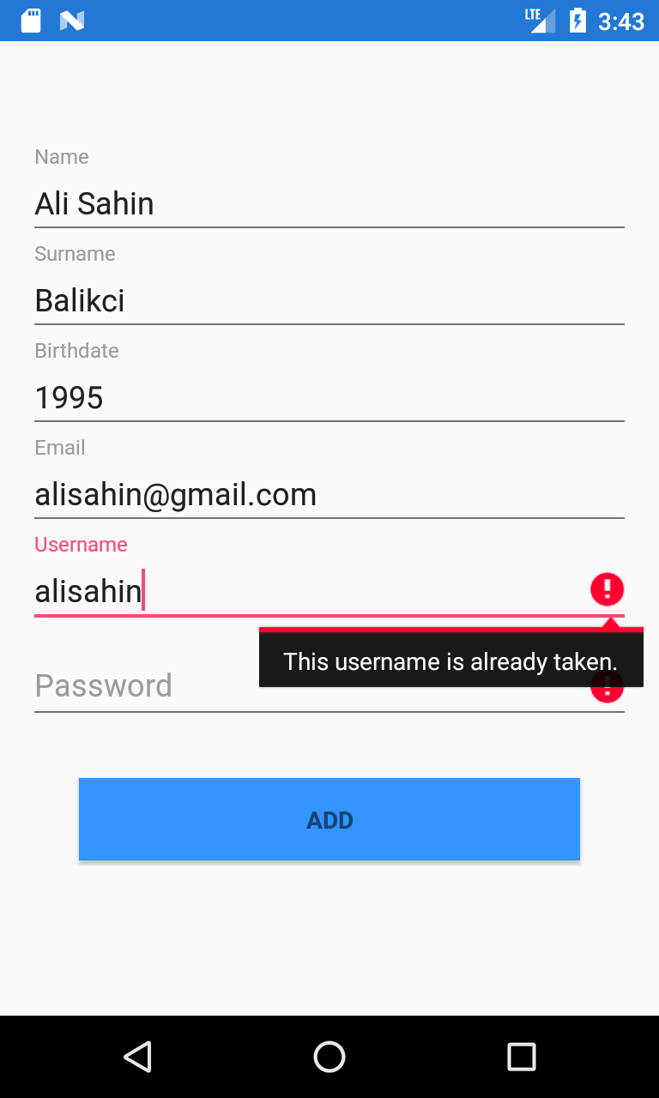

1. **ManagerManagementScreen: Successfully added**

**UserManagementScreen: Successfully added**

**TrainerManagementScreen: Successfully added**

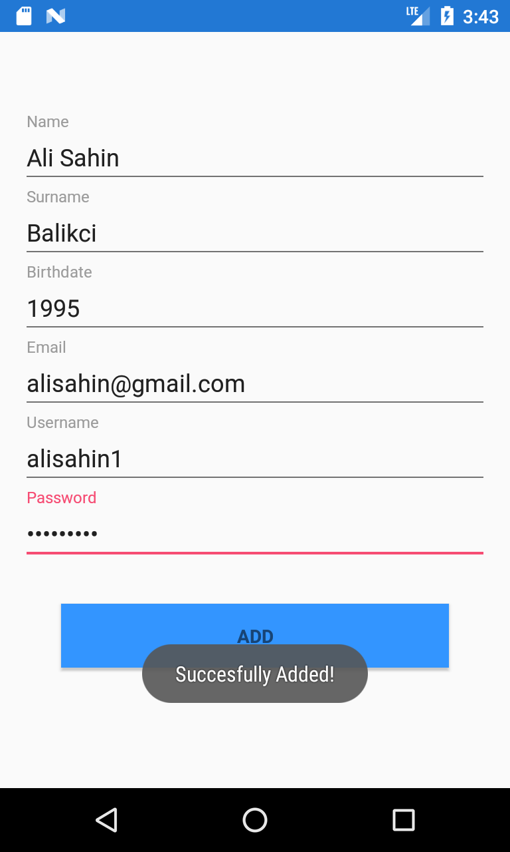

1. **ManagerManagementScreen: Successfully updated**

**UserManagementScreen: Successfully updated**

**TrainerManagementScreen: Successfully updated**

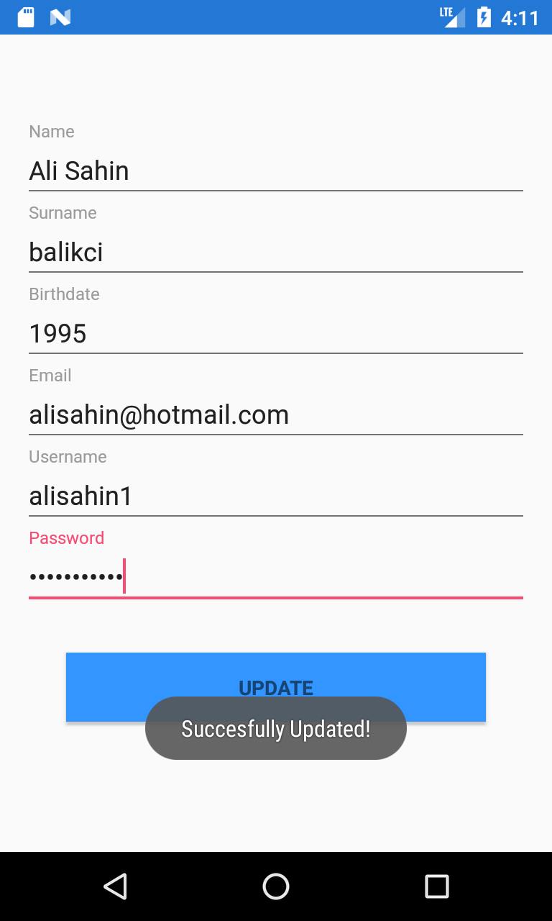

1. **ManagerManagementScreen: Successfully deleted**

**UserManagementScreen: Successfully deleted**

**TrainerManagementScreen: Successfully deleted**



1. **FragmentMyProfile: Branch fullness**

